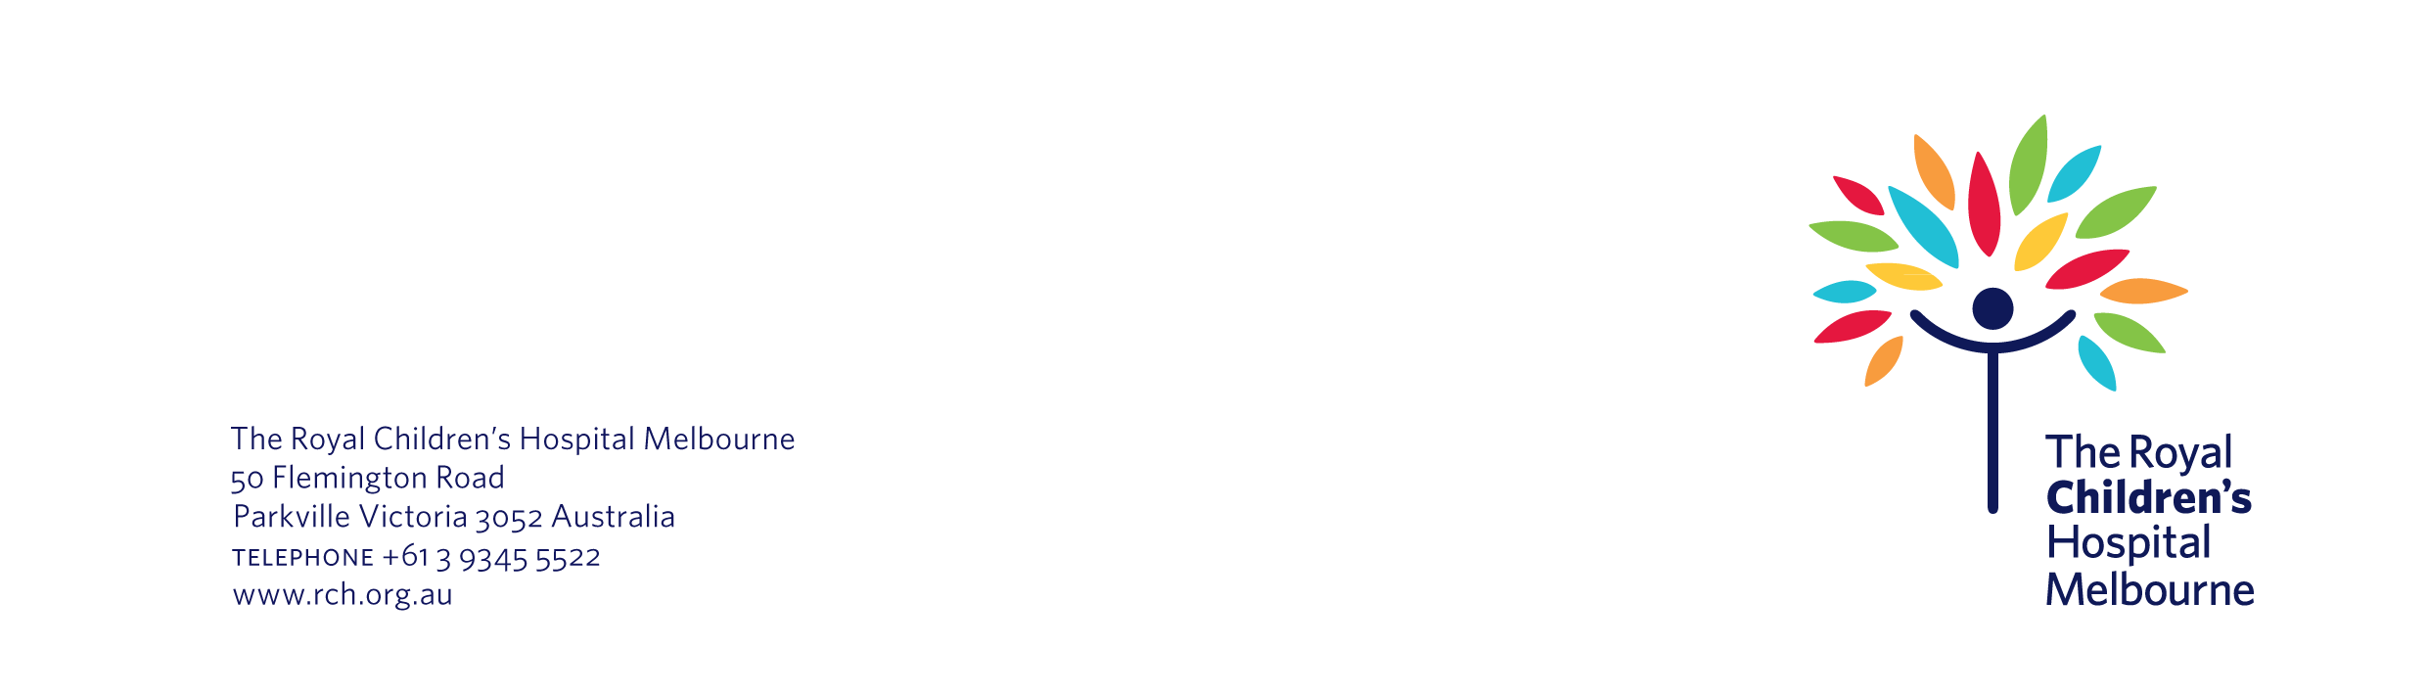
10 January 2020

Re: | Thank you for your help with the Good Night, Sleep Tight Program
Study number: | 12345

Dear Ms Ng

I am writing to thank you and your son Johnny for taking part in the Good Night, Sleep Tight Study (the study). All of us at the Better Sleep Clinic appreciate the time and effort that you and Johnny put into the study.

As you may recall, the study looked at whether deep breathing techniques, massage and reflexology could be used to treat behavioural sleep issues in children. A total of 64 children took part in the study. The study finished in May this year and we have now analysed the findings.

Study findings

We are pleased to tell you that the study generated some positive results. There were 64 children who took part in the study. After completing the study:

- half were able to fall asleep more quickly at night
- two thirds reported improvements in their emotional wellbeing
- two thirds continued to use deep breathing, massage and reflexology techniques after they completed the program. Most of them said that they were using these techniques as part of a nice bedtime ritual, and not because there were continued sleep problems.

We will use the study findings to help other children at the Better Sleep Clinic. We also hope to use the findings to assist children with sleep issues in Australia and abroad. For example, our colleagues have presented the study findings at conferences in Australia, the United Kingdom and Brazil. We have also published an article in the December issue of The International Sleep Journal.

If you would like any more information about the project, please contact me by phone on (03) 8888 7777 or by email on hazelnutt@rch.org.au.

Thank you again for taking part in the project. You and Johnny have helped us find ways to promote better sleep for children in Australia and beyond.

Yours sincerely,

Professor Hazel Nutt
Principal Investigator
Better Sleep Clinic
The Royal Children’s Hospital Melbourne

